**Dice Game Fitness 1**

Get 2 Dice and Roll the dice. Add the dots up on the dice to get your number. Perform the task assigned to the number rolled. You may modify the movements as needed. Perform at least 8 reps of the activities. You can do as many reps as you want above 8 reps.

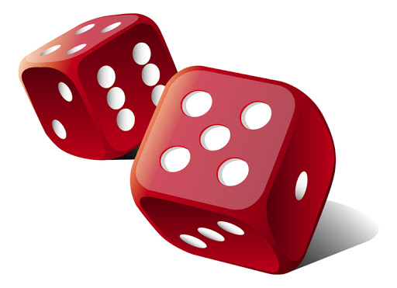

|  |  |  |  |
| --- | --- | --- | --- |
| 1 | Jumping Jacks  Wacky/Crazy Jacks | 7 | Toe Touches |
| 2 | Wall Push-ups | 8 | Give Self Hug |
| 3 | Punch Outs | 9 | Run In Place or March |
| 4 | Jump or Hop on 1 or 2 feet | 10 | Balance move |
| 5 | Dance or Move Your Body | 11 | Stretch Move |
| 6 | Perform a Sports Move | 12 | Create Your Own Move |